**Presenting Obstacles Around An Airport Aerodrome Using Google Earth Pro and Here Maps API**

**Team Members:**

**Vedant Sahai**

**Shubham Pednekar**

**Elvis Dsouza**

**Jason D’Costa**

**Pratik Chowdhury**

**Arpita Isaac**

**Abstract:**

Records of all the obstacle such as the trees, buildings, hoardings, towers etc, located around an airports aerodrome are maintained in AD 2.10 section of the AIP documentation which is published on the Airport Authority of India's website ( <https://aim-india.aai.aero/aip-supplements> ). The current version of AIP can be downloaded in the PDF document format.The PDF lists every obstacle with its latitude, longitude, base elevation, top elevation, height and object category in its description in a tabular format.With the help of this data given in the PDF, open-source geolocation data handling file format like KML, the data of obstacles around an aerodrome can be conveniently represented on every popular 2D or 3D mapping engines like the Google Earth Engine, Google Maps, and many more.

**Introduction:**

A series of surfaces that define the volume of airspace at and around an aerodrome to be kept free of obstacles in order to permit the intended aircraft operations to be conducted safely and to prevent the aerodrome from becoming unusable by the growth of obstacles around the aerodrome.

Since the current representation of geographic data in latitude, longitude format is very inconvenient for the interpreter to pinpoint the obstacles in the field especially the common obstacles like a group of trees, electric poles, etc. Hence a user based interface for viewing these obstacles in 2D and 3D formats on Google Earth Pro and HereMaps API helps the concerned authorities to analyze the data in an effective way.

The sole purpose of this system is to promulgate supplementary guidance materials to aerodrome operators and development authorities to keep control of obstacles being built around an airport. The AIP documentation aims to provide guidance on what is acceptable to the Aerodrome and Air Navigation Services Regulation (AAR) with regards to the rule and regulations of the Ministry of Civil Aviation, Government of India. The Annex 14 document recommends and explains the process of obstacle control, which is marking and lighting of obstacles, conducting of obstacle surveys, removal or lowering of obstacles and reporting of obstacles to the appropriate authorities. By using our system fully, the aerodrome operator should be able to establish an effective obstacle control process and keep his aerodrome and its vicinity safe for aircraft operations.

**Requirements:**

Server:

FTP / HTTP File handling

REST API and Flask

KML and KMZ File Database

Python and .NET Database Creator

PostgreSQL Database

PDF Data Scraping

Client and Administrator:

Google Earth Platform

Web Browser

Here Maps

Internet Connection

**System Design:**

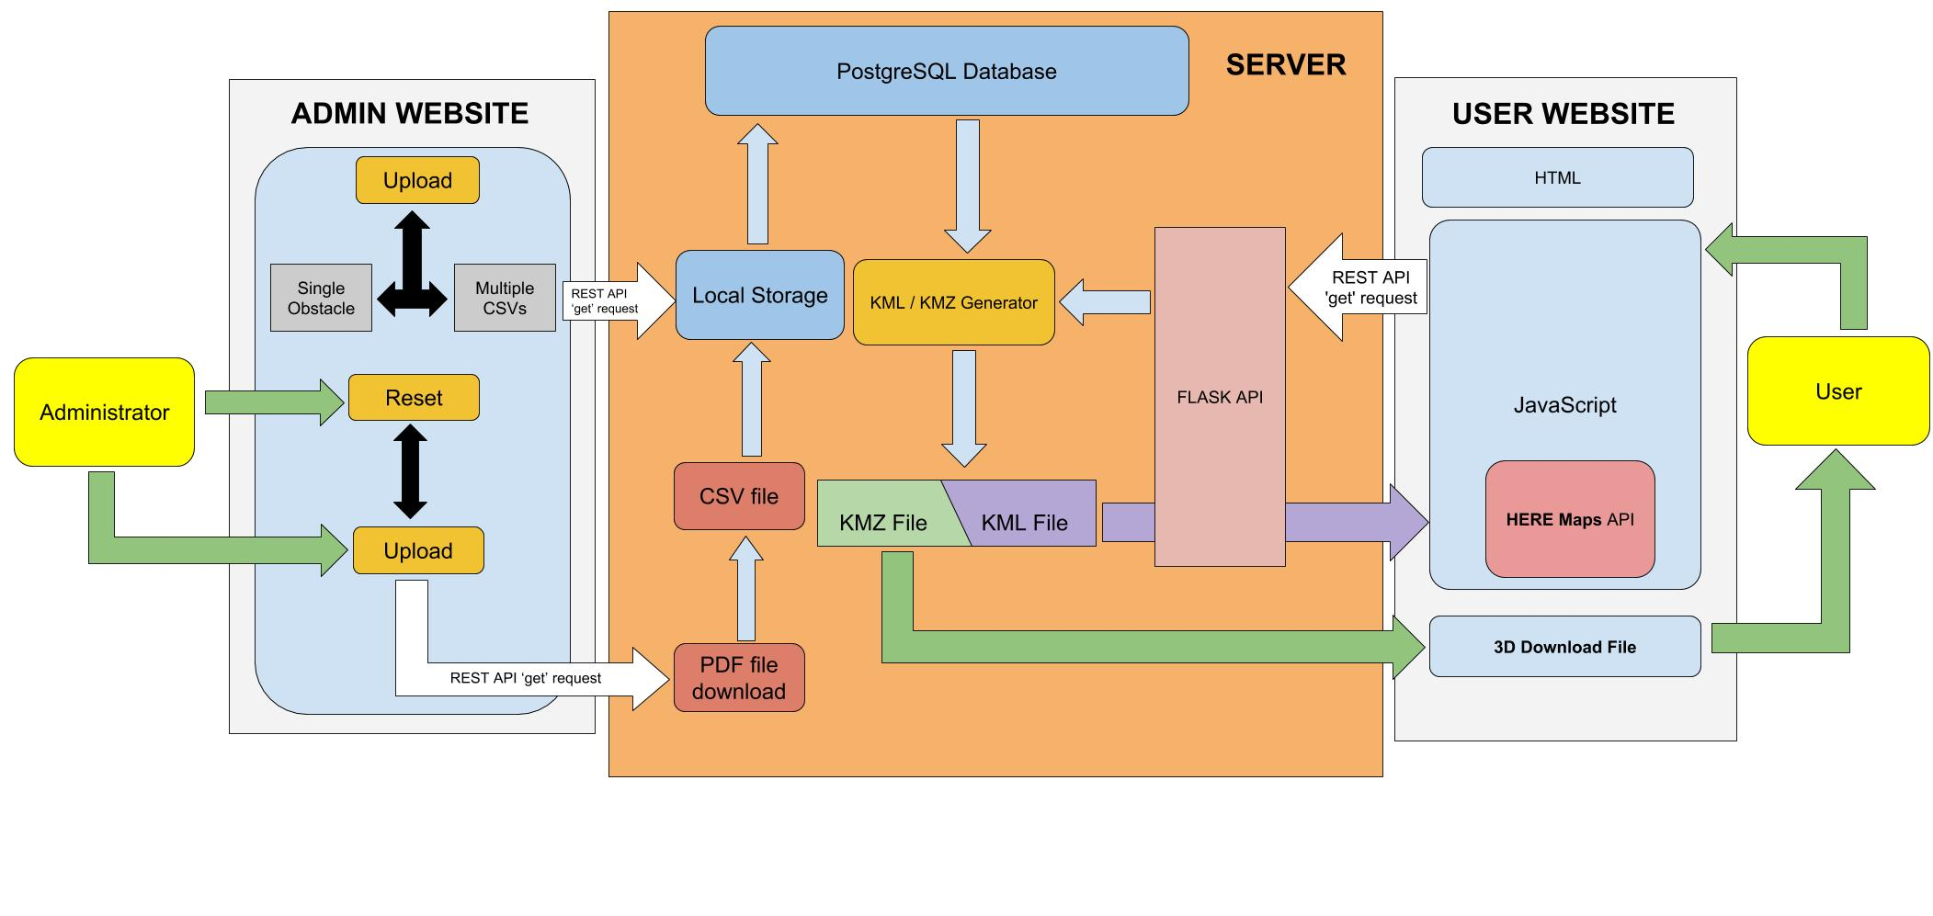

Block Diagram

The whole of the project can be divided into three main categories which are as follows -

* The Administrator
* The Server
* The User

Now getting into the details of each of the above-given categories we have:

1.] The Administrator:-

* The administrator has access to the database and thus can manipulate the obstacles according to his needs.
* We have created a login website for the Admin wherein he/she will have to enter his/her login credentials in order to get system access to manipulate it.
* Once the login is successful, the administrator sees four buttons namely -

1. Update - Clicking on this button leads to updating of the system automatically including the database by a python script called by the server which calls the other existing python script. In this case, the database is just updated i.e. added or overwritten but nothing is deleted.
2. Upload - Clicking on this button the administrator has further two options which are UPLOAD CSV and UPLOAD SINGLE OBSTACLE. In the Upload CSV part, multiple CSVs can be uploaded at a time containing the obstacles data in a standardized format which will append itself in the database. While the Upload Single Obstacle option can be used to manually enter the data of a single obstacle to the system by entering the required information manually
3. Hard Reset - Clicking on this button the system goes into reset mode that is the database is completely wiped off and again the updating process starts leading to new data entries being added in the database.

NOTE:

In the Hard-Reset button, the database is completely deleted and new entries are added in the database. Whereas in the Update button there is no entry deletion in the database, it just adds new entries to it or simply overwrites.

2.] The Server: -

* The Server is the main backbone of the project. It is due to this server that we are able to generate 2D and 3D files dynamically that is it is generated on the user's demand.
* The Server is built using the RESTful API with the help of high-level languages Python.
* The server includes a PostgreSQL database in order to store all the CSV data at a single location.
* When the administrator presses the Update button via the Admin Website, the server is the one responsible for the whole system operation.

The Updating/Hard Reset process includes the following flow:

1. Auto Downloading of the AIP documents from Airport Authority of India site to the cloud where these downloaded pdfs are scrapped and then converted into corresponding CSV files.
2. Once the CSVs are generated, a python program adds this obstacle data from the CSVs to the Aerodrome SQL database which lies on the server arranged according to the Airport Code inside it.
3. With the help of this database 2D KML files,3D KMZs files and the corresponding Network Link of 3D files are generated and are stored which can be accessed by the User on the front end side.

* The interaction between the cloud and the front end is established using the RESTful API which an application program interface (**API**) that uses HTTP requests to GET, PUT, POST and DELETE data.
* REST API uses Python-Flask as its libraries in order to coordinate between different parts of the system by sending various request over the internet.

NOTE:

The Upload button skips the early stages of the upload process and directly adds the data in the database.

3.] The User: -

* The User has a website for him/her in order to see the obstacle data in the graphics format.
* The website is built using HTML5, CSS3, Bootstrap and JavaScript along with jQuery’s.
* The homepage of the website contains all the names of the airport in a list format with a search bar on the top for the Users convenience.
* On clicking on any one of the airport’s names the User further gets two options which are to **Preview in 2D** on HereMaps or to **Download in 3D** by downloading the corresponding Network Link which can be opened on the Google Earth Pro.
* Clicking on the Preview in 2D, HereMaps are opened on a new tab which contains all the obstacles plotted on it represented by placemarks along with their metadata.
* Clicking on Download in 3D starts a downloading process of a network link file for that airport which is to be opened on Google Earth Pro.
* The system also provides the User advance search button wherein he/she can filter out search details and can see the data in a list, 2D or 3D format.

NOTE:

The data formats returned are JSON (list), KMLs (2D) and KMZs (3D) which are generated dynamically by the server with the help of the database.

**Terminologies Used:**

1.] Keyhole Markup Language (KML) : XML based file format to encode

geographic data.

2.] Keyhole Markup Zipped (KMZ) : Compressed file that stores KML

and 3D object files as a single

entity

3.] Network Link : Hyperlinks that link to KMZ files

hosted on the server

4.] 3D Object Files : Store 3D object models and

Textures

5.] Google Earth Platform : GUI platform that renders KMZ files

in a user-friendly interface

6.] File Handling Protocol : Protocol that hosts files on the

server.

**Testing:**

KML and KMZ file formats provided by Google is used to map geographical placemarks and 3D objects on Google's mapping technologies.

Generating the Obstacle Surface Limitation models and its layers of polygons, graphical algorithms and vectorization were utilized.

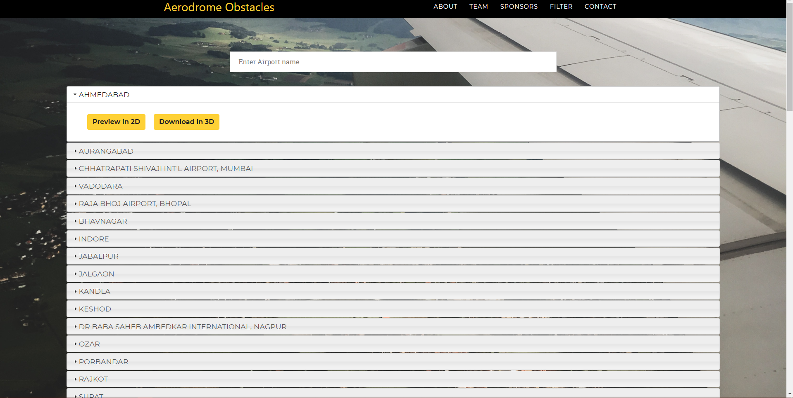

Fig 1: The Homepage

The homepage of the website has a search bar to search for the names of the airport and each airport has two options for the user to see the obstacles graphically.

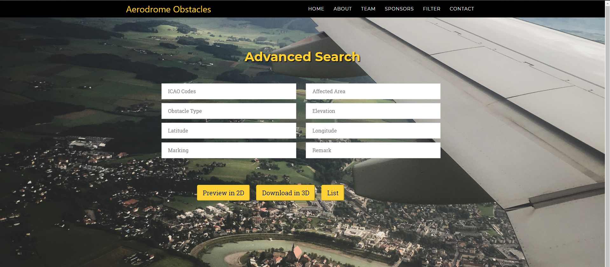

Fig 2: Filter

This is the advanced search filter implemented in our website which has the various parameters where the user needs to fill his requirements see the result in List,2D or 3D format.

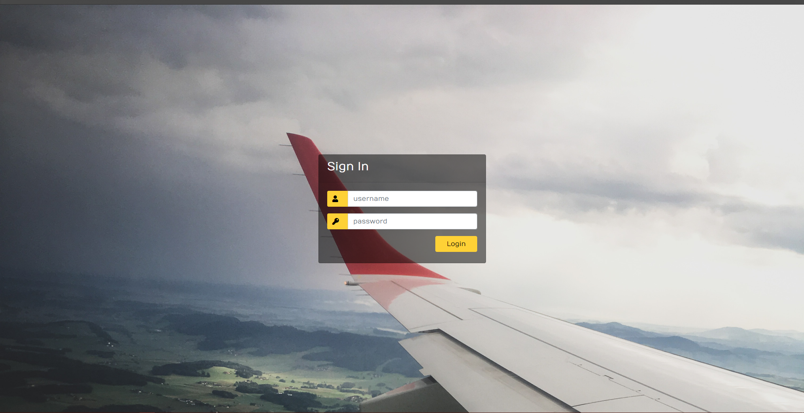

Fig 3: Admin Login

The Admin Login is a separate website all together for the Administrator which is not included in the main homepage and a separate URL which the administrator will only know about After successful login into the system the administrator will have the following operations to manipulate the system.

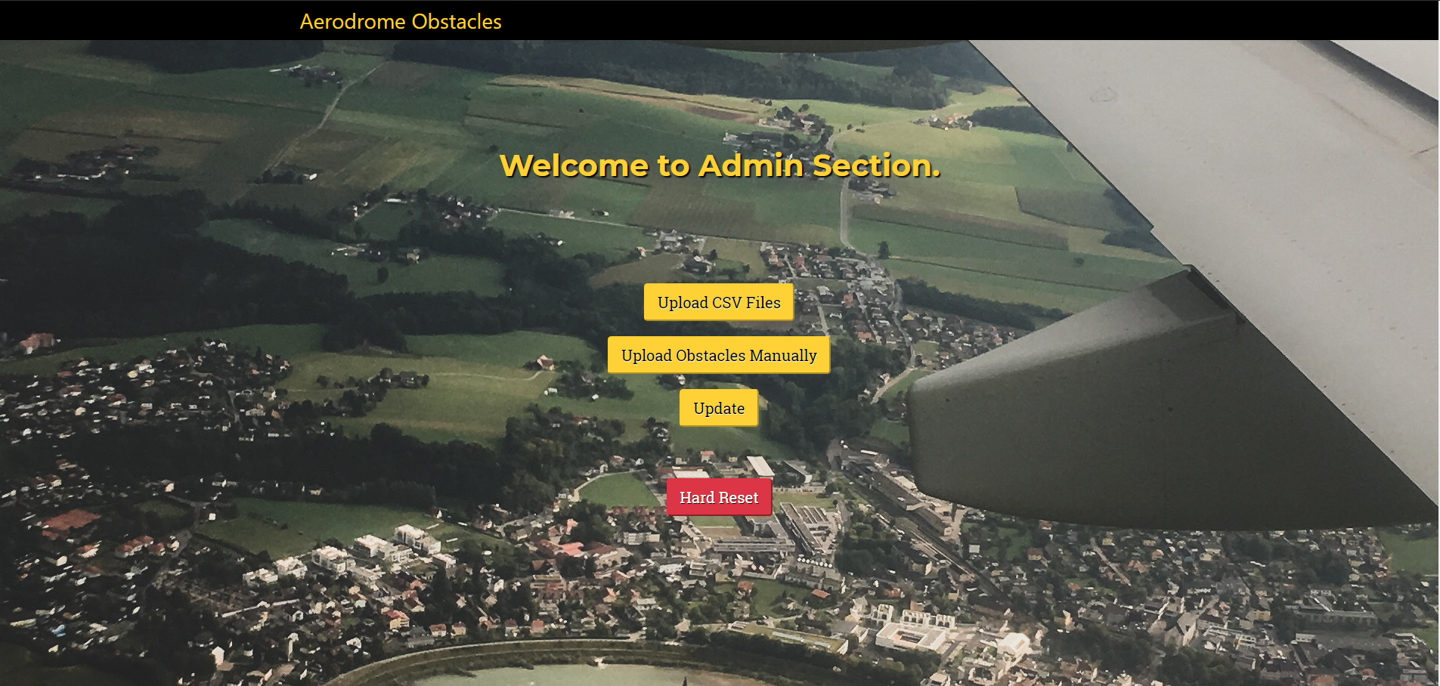

Fig 4: Admin Section

Finally, the output of our system will be the graphical representation of the obstacles in the 2D or 3D format on HereMaps and Google Earth Pro respectively, which is shown below in the diagrams

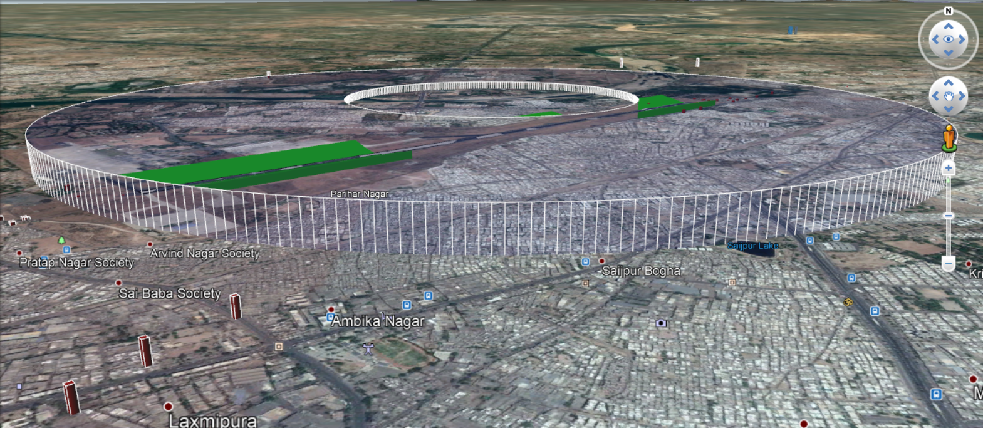

Fig 5: 3d View

The placemarks or the models depending on the view has its metadata along with it which can be seen on clicking the model or the placemark.

The 2D view has the option to download that airport in 3D if the user feels he/she may get more information about the obstacle by seeing it in 3D.

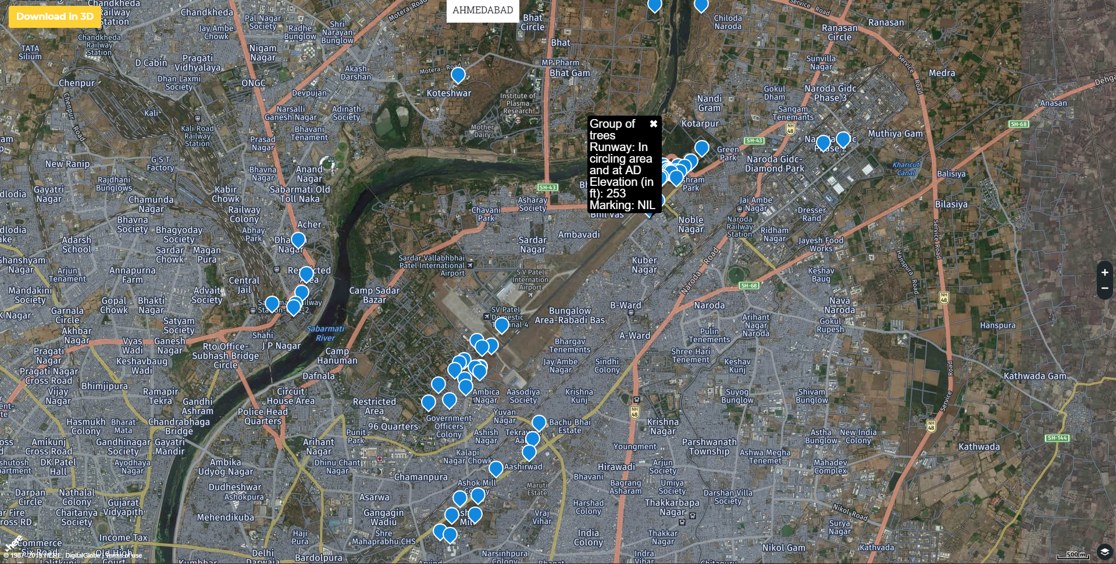

Fig 6: 2D View

**Conclusion:**

This project aims to create an interactive, dynamic and real-time interface to map obstacles present in and near Indian aerodromes virtually.

It provides benefits to its users, some which are, apart from civilians, also to pilots, air traffic controllers, defense personnel, security agencies, government officials, etc.

This project is built upon the fundamentals of scalability, affordability, expandability and versatility while retaining simplicity and ease of deployment.